Attachment A: Project Narrative Template

A.1 PROJECT LOCATION AND DESCRIPTION
PUBLIC SPACE

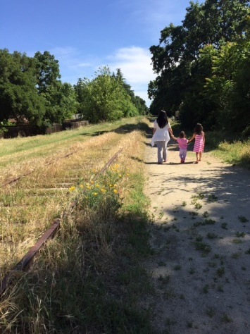
The Del Rio Trail project is in the City of Sacramento along a five-mile abandoned railway corridor to the west of Freeport Boulevard from approximately Sutterville Road to the north and Pocket Road to the south. The corridor was previously occupied by the Sacramento Southern Railroad’s Walnut Grove Branch Line but was abandoned in 1978. Sacramento Regional Transit acquired the property in 1984 as an alternative alignment of their light rail system to South Sacramento, but ultimately selected a different alignment that rendered the corridor surplus property. The City of Sacramento acquired the property in 2021 in an agreement to develop the corridor as a multi-use trail and linear park with direct connections and wayfinding to Regional Transit’s bus stops. To address equity for all residents of Sacramento and to support public space conditions where everyone can be healthy, the Del Rio Trail project combines the creation of a trail-park infrastructure with community engaged public art along this vital pedestrian corridor.
The corridor includes approximately 63 acres of land and runs through the City’s Land Park, South Land Park, Freeport Manor, Z’Berg, Pocket, and Meadowview neighborhoods. The corridor is visible to the public along Freeport Boulevard and at the eight at-grade road crossings within the project’s limits. There is no formal public access to the corridor, although some residents use portions of it informally for recreational purposes. Other portions are largely inaccessible due to topography and overgrown vegetation. Illegal dumping has historically been a problem on the corridor due to its fallow appearance and proximity to major roadways.

The corridor has been identified in the City of Sacramento’s Bicycle Master Plan as a critical active transportation connection for the adjacent community and the City’s overall multi-modal network. Public art included in this project will give community residents an opportunity to work directly with local and national artists to share and celebrate the art and culture that makes Sacramento neighborhoods unique and welcoming. The Del Rio Trail project proposes to construct approximately 5 miles of Class 1 multi-use trail that will connect the Sacramento River Parkway at the northern end of the corridor with the Freeport Shores Trail at the southern end of the corridor. When completed, the trail will be an activated public space including creative placemaking and public art all maintained by the City as a parkway.

PROJECT DETAILS

The proposed Del Rio Trail Project will consist of a Class I multi-use trail varying in width from 12 to 16 feet of pavement with unpaved shoulders generally ranging from 2 to 3 feet. The project will include a separated overcrossing of Interstate 5 and eight at-grade crossings of local streets. Trail crossing improvements at the eight at-grade crossings vary depending on traffic volume and speed including new marked crosswalks with rapid rectangular flashing beacons, pedestrian actuated traffic signals, and in some cases utilization of existing signalized crossings. Each of these crossings provides the City an opportunity for public artwork and wayfinding that will help activate the corridor and reduce incidents of illegal dumping that are currently occurring within the project’s limits. All of this new public infrastructure works to support healthy communities through safe and culturally relevant public space, adding to the overall wellbeing and public health of the city’s residents and visitors.
ART INSTALLATIONS

Art has the ability to connect people, and along a trail setting, these connections also provide a public health benefit through interactions with nature, culture, and community engagement in the design process. The art component of this trail would be broken into two main categories: wayfinding art and placemaking or gathering art locations:

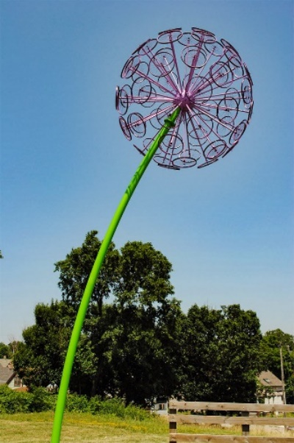
As a wayfinding element, public art operates through visual stimulation and symbols. The project will include up to twenty sculptures on posts or other artistic designs that help guide people along the trail. The trail will be broken into up to five zones with each provided an artist to design wayfinding elements along their zone. These wayfinding elements are particularly important at the entrance and end of the trail zones along the river but will be continuous throughout the length of the pathway. Artists will be encouraged to create sculpture designs such as sculptures on standard poles that can be easily installed and provide visible wayfinding elements. Along this five-mile stretch of trail, the pole sculptures will serve as visual markers and lead path goers forward.

Up to four locations will also be identified as gathering locations. Distinguished from the wayfinding projects, these gathering locations are a place of rest or contemplation along the trail. Artists will have the opportunity to work with local community stakeholders to discuss themes and concepts important to these local neighborhoods.

For example, historic steam train enthusiasts have been actively engaged in the project. Further north, where the rail line is still operational, the Sacramento Railroad History Museum the line is a major cultural and tourist attraction and operates historic locomotives along the waterfront. The gathering locations could be areas to celebrate trains and train history through art along with other historic themes related to Sacramento’s celebrated farm to fork culture. Potentially using upcycled elements from trains or train tracks, artists will have the opportunity to create plaza-like gathering spaces or sculptures that might involve varying materials and themes. Artists will work with community stakeholders to discuss ideas and gather insights about the specific communities that utilize the areas where the spaces are located. Each plaza space may be designed by a different artist, allowing users the opportunity to “visit” each space along the trail. Community members from the different neighborhoods will be engaged through a community engagement process allowing the artists additional inspiration and content to consider in their design development. This process of engagement also strengthens a community’s public health. Many studies show how personal interactions and connectiveness to others around you provides a sense of wellbeing and inclusiveness. This coupled with safe and attractive green spaces will allow residents to both connect to other areas of the city and connect with one another in transformative and supportive ways through art and culture.

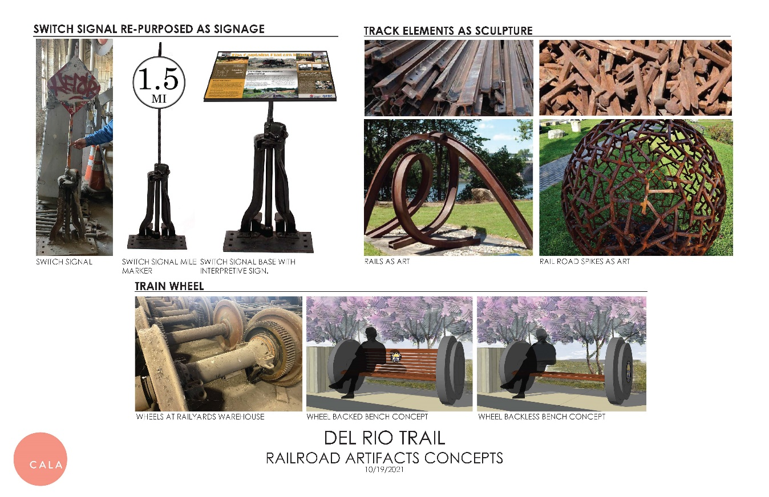
Through a dynamic approach including both wayfinding elements and gathering spaces, the trail experience will allow city residents and visitors to have a unique sense of “passing through” Sacramento communities highlighted through the vision of artists who have worked with and been inspired by these neighborhood residents.

ASSOCIATED CALTRANS PROJECTS

Not Applicable

A.2 DEMONSTRATED COMMUNITY NEED
GOAL 1: REDUCE WASTE AND DEBRIS

The project is being constructed within an existing abandoned railway corridor with a history of illegal dumping. Over a two-year period from 2019 to 2021, the City of Sacramento responded to 247 incidents of illegal dumping on the corridor that included trash, old furniture, and constructure materials. This equates to almost 500 cubic yards of debris removal in a two-year period assuming an average of 2 cubic yards of removal per incident. The City of Sacramento is currently responsible for waste removal and will continue to be at the end of the project.

As part of the Del Rio project, the City will also be perfecting its property rights. The City has identified approximately 70 private property encroachments into public space that are being addressed with the project. Encroachments into the public space include abandoned fences and sheds, junk storage, concrete pads, and used construction supplies. As part of the project, the City will be removing these encroachments and cleaning these spaces for public use.

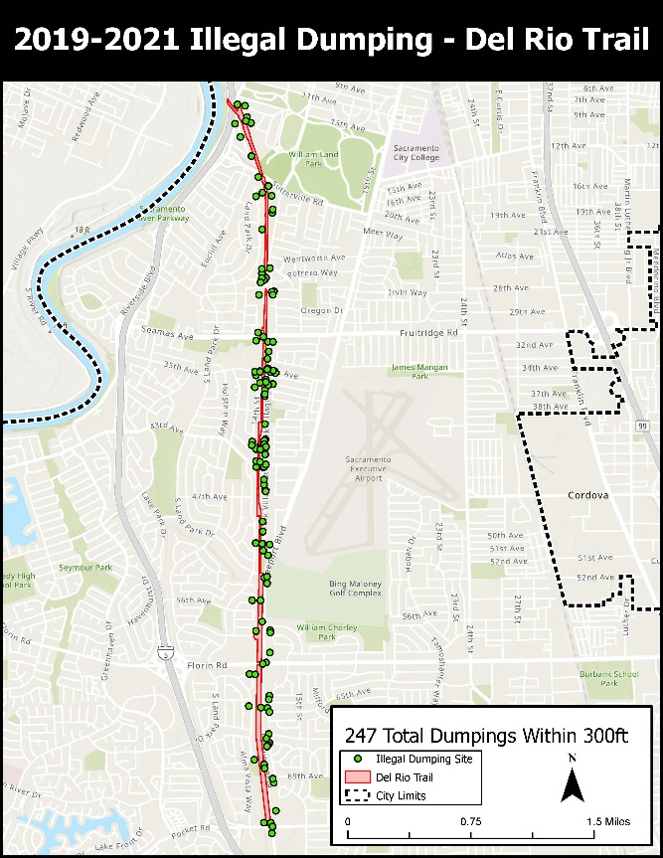
Construction of the trail will activate and increase usage along the entire corridor. The increased recreational usage will discourage illegal dumping and littering common along undeveloped corridors. In addition, the presence of the trail will allow maintenance staff to access and maintain the corridor more easily.
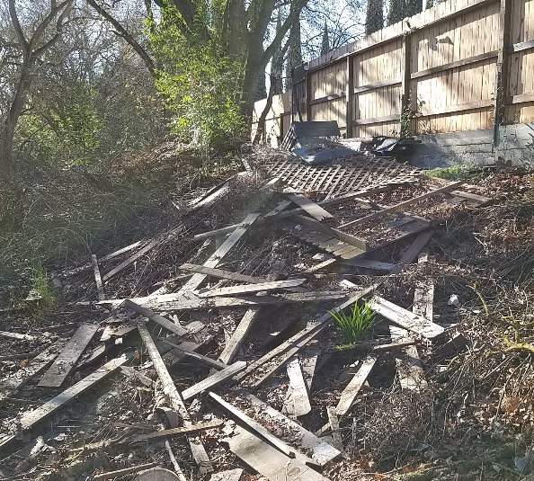
GOAL 2: BEAUTIFY AND IMPROVE PUBLIC SPACE

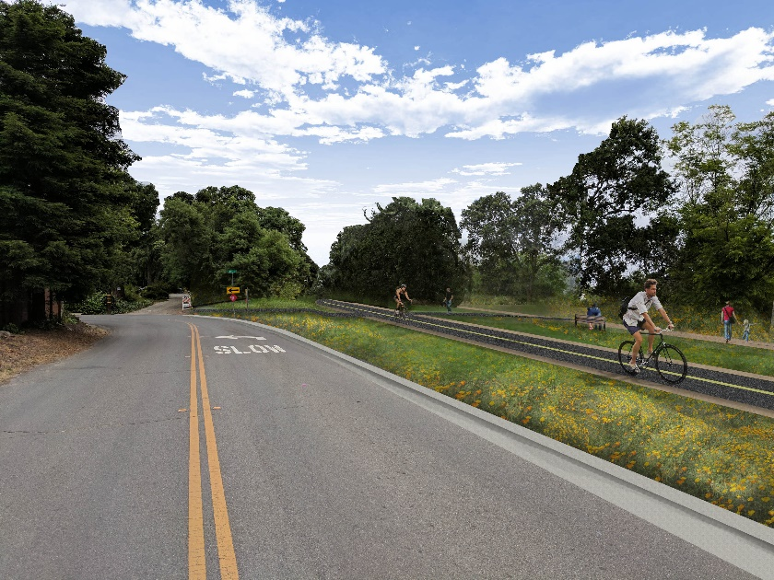
The project will reclaim sixty-two acres of an abandoned railroad corridor and repurpose it for public use. This includes constructing approximately 5-miles of shared use paths that are compliant with the Americans with Disabilities Act and cleaning approximately 35 acres of natural space so that it can be enjoyed by the public. The project will also plant 700 trees along the corridor to augment the existing tree canopy.

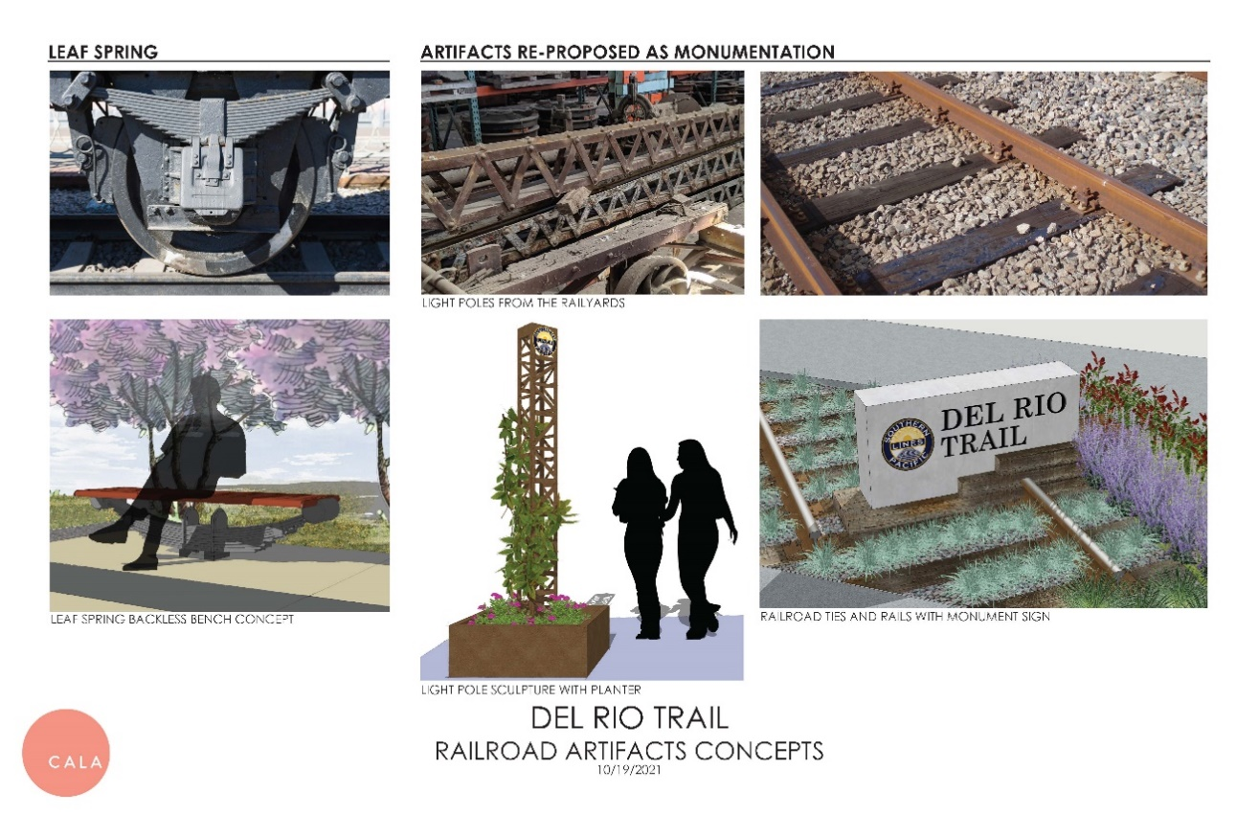
The public art component of the project will include up to twenty art sculptures and up to four gathering spaces. The project has environmentally cleared the repurposing of existing railroad artifacts to highlight the historic use of the corridor. These elements could include using old switch signals for interpretive signage, creating art sculptures out of old railroad track or spikes, using train wheels or leaf springs as public benches, or making vertical wayfinding elements out of old railroad light poles. This effort has been coordinated with State Parks and the Sacramento Railroad Museum who has surplus railroad artifacts that they have offered to be repurposed. Examples of what this could entail were shown in the response A.1 and below.

GOAL 3: IMPROVING PUBLIC SPACES FOR WALKING AND RECREATION

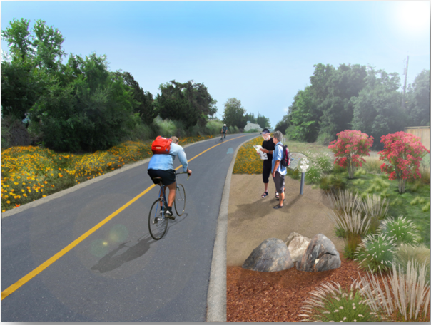
The Del Rio Trail will complete a planned trail connection between the Sacramento River Parkway and the Freeport Shores Bikeway in accordance with the City’s Bikeway Master Plan. The trail will connect logical origins and destinations proximate to the corridor by improving pedestrian and bicycle access throughout the South Land Park, Freeport Manor, Z’Berg, Land Park, Meadowview, and Pocket neighborhoods. The Del Rio Trail Project is needed because these communities in South Sacramento currently have limited ADA‐compliant, active modes of transportation access to schools, retail, jobs, and recreational amenities. This increases automotive dependency and vehicle miles traveled, while reducing opportunities for those who do not drive or do not have access to a car including children, the elderly, the disadvantaged, and persons with disabilities.

In addition, planned public art components through wayfinding and placemaking / gathering space designs, adds to a community’s public health and well-being. Engagement in the public art design process provides community members an opportunity for positive self-awareness and recognition, conditions central to mental and physical well-being. The connectivity described above combined with wayfinding artwork also provides clear and defined direction as one passes along the park space. These reoccurring artistic interventions both highlight the community identity of those involved and provide attractions and culturally relevant experiences for residents and visitors alike.

GOAL 4: ADVANCE EQUITY FOR UNDERSERVED COMMUNITIES

The total project length is approximately 5 miles long and runs through some of the more affluent neighborhoods in Sacramento. This skews the severity of disadvantage calculation for the project towards a higher grant match percentage but doesn’t reflect the benefits of the trail to the City’s underserved community. Nearly all of the census tracts to the east and south of the trail qualify as underserved per median income census data. This is particularly true for the southern end of the project which includes Census Tract 43 with a population of 9,867 and a median income of $49,154. This tract alone accounts for 19% of the 52,354 residents adjacent to the trail. The total population adjacent to the trail with a median income of less than $60,188 is 30,280, or approximately 58% of the total population.

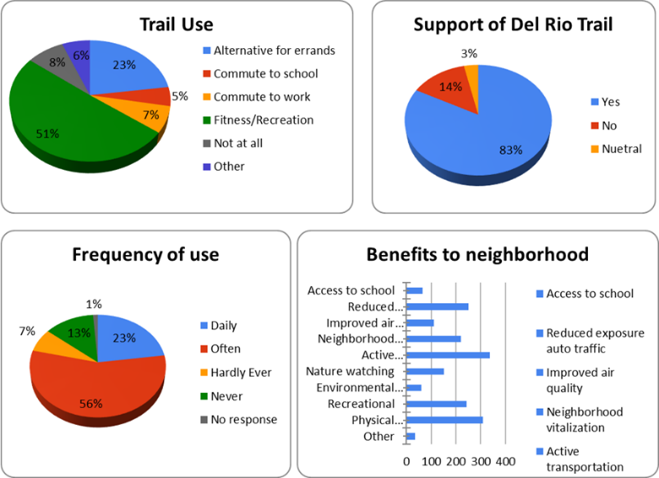
The topography and ground vegetation on the southern half of the corridor serving this neighborhood currently precludes walking or bicycling. This creates a significant active transportation barrier for residents who may not have access to Downtown Sacramento and its many commercial, social services, and recreational opportunities. Without the project, these users must use Freeport Boulevard which is a four-lane arterial with narrow bike lanes and no sidewalk.

This use of the trail is corroborated in a survey that was circulated to the surrounding community as part of the public engagement process. The survey received over 600 responses that showed that 79% of respondents would use the trail daily or often, 51% of respondents would use the trail for recreational uses, and 35% of respondents would use the trail for commuting purposes (trips to school/work or as an alternative for errands).

The City will work directly with underserved community members to design the artwork on the trail. Historic marginalization of these communities has created an isolated area where residents are geographically separated from the city center and access to art, culture, and recreation areas – vital to a healthy and engaged lifestyle. Research has shown that place-based art and culture projects create opportunities to address “collective trauma, racism, social isolation and exclusion, mental health, and certain chronic diseases” (Sonke et al., 2019). “Accessing parks and green space has a demonstrated impact on mental health, social isolation and exclusion, and chronic disease, not to mention indirect benefits of reducing heat islands and stormwater runoff” (Gies, 2016).

These things are not just “nice to have” or “pretty to look at”, they signal the city’s investment in all residents and all areas of city life. Public art can add to this experience. “Recent scholarship has shown remarkable connection between exposure to artistic practices and positive individual health outcomes. In the United States and the United Kingdom, this evidence has shown that populations are healthier with access to the arts and with the presence of strong and diverse arts sectors” (The Toolkit for Health, Arts, Parks, and Equity, The Trust for Public Land). Recognizing the benefits that arts and culture provide along with healthy green spaces for travel and recreation, this project seeks to combine these elements along an historic and strategic pedestrian corridor.

A.3 PUBLIC ENGAGEMENT
PREVIOUS PUBLIC ENGAGEMENT

The Del Rio Trail is identified in the City of Sacramento’s 2035 General Plan, 2018 Bicycle Master Plan, and the Sacramento Area Council of Government’s Trails Master Plan. The project is unique in that it evolved through a community-driven effort to develop the railroad corridor. In 2014, the South Land Park Neighborhood Association (SPLNA) mobilized a Right of Way Conversion Steering Committee whose priority was to engage stakeholders including Regional Transit, the City of Sacramento, and State Senator Darrell Steinberg (now the mayor of Sacramento) to convert the corridor from an abandoned railroad corridor to an active transportation asset for the community. The City of Sacramento was able to secure funding for the project and established a Capital Improvement Project in 2016 for environmental clearance, design, and construction of the trail.

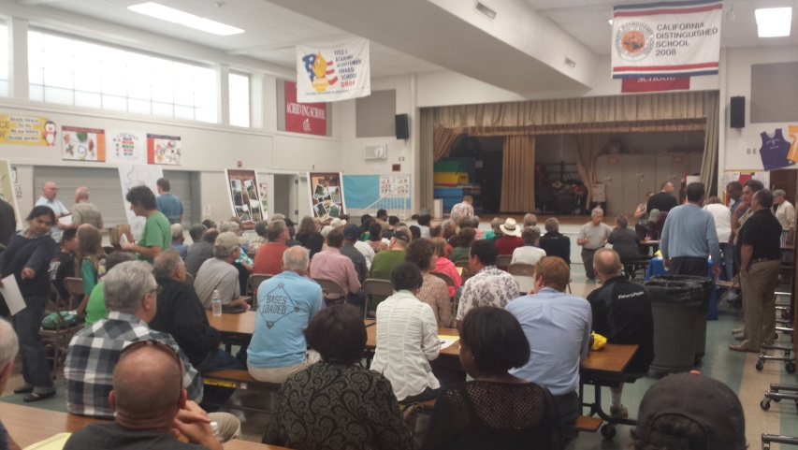
Extensive public outreach was performed during the PA&ED and PS&E phases of work to inform the public about the project and collect feedback on the overall design of the corridor. Stakeholders include residents, business owners, property owners, and elected officials; neighborhood associations including SLPNA, Cabrillo, and Land Park; local walking and bicycling groups including the Sacramento Area Bicycle Advocates and Walk Sacramento (now known as Civic Thread); disability groups including members of Access Leisure; and project partners including Regional Transit, California State Parks, City of Sacramento Police Department, City of Sacramento Park Rangers, Caltrans, and the California Transportation Commission. Prior to environmental clearance in 2019 the City held four public meetings, four neighborhood meetings, presented to nine different organizations, held two neighborhood events, and had four focused meetings with the public on specific project issues. It is estimated that over 2,100 community members have engaged on the project, including almost 600 who are currently registered in a stakeholder database and receive project updates and meeting invitations as appropriate. The project has been overwhelming supported by the community. In a project survey with over 600 responses, 83% of the respondents were in favor of the trail and public support for the trail has not waned as the project nears construction.

Feedback from the public has been instrumental in developing the current project plans. For example, focused meetings with residents near the Normandy and Del Rio Road intersection were held specifically to discuss their access to nearby Sutterville Elementary School and concerns about the intersection. The resulting ADA-improvements and reconfiguration of the intersection are a direct result of their input.

PUBLIC ENGAGEMENT WITH THIS PROPOSAL

If this grant application is successful, the public will have additional opportunities to influence the project in a significant way. Beatifying public space through a public engagement process will allows residents to take ownership of these spaces through their own personal connections to the design and planning process. Community members will have the opportunity to work with artists in both the wayfinding and gathering space concepts through public meetings and workshops, providing vital insights and inspiration for artistic and creative design development with their specialized knowledge of the area. Artists will have the time and funding to work directly with these community stakeholders to engage them in an active dialogue about the trail, their interests, and the locations that make the most sense to locate artwork or gathering spaces. The selected artists for the project will develop their own vision, but they will be able to utilize and react to the insights they receive in public meetings and design workshops. This layered approach to engagement will allow artists the opportunity to be creative while directly responding to community input and guidance.

A.4 PROJECT DELIVERABILITY
PROJECT DELIVERABILITY

The project is currently nearing completion of design with construction anticipated later this year. The Clean California Grant will be used to close a construction funding gap for artwork that has been environmentally cleared but doesn’t have an identified funding source, and additional cleaning and debris removal that is currently underfunded with the existing construction budget. Permits required for the project and their status are listed below:

Responsible Agency | Permit/Approval | Status
RWQCB | NPDES 402 Construction General Permit | In Progress
CVFPB | Encroachment Permit | Complete
DWR Maintenance Area 9 | Encroachment Permit | Complete
SAFCA | Construction Timing Coordination. | Complete
CDFW | Section 1602 Streambed Alteration Agreement | Complete
U.S. Army Corps of Engineers | Section 408 Permit | Complete
CPUC | General Order 88 review | Complete
Caltrans | Encroachment Permit | In Progress
City of Sacramento | Tree Removal Permit | In Progress

PROJECT RISKS

Project Risks are minimal for the project as it is environmentally cleared with 100% design plans that are currently being finalized. Most permits needed for the project have been approved as listed above. The remaining permits are in progress. The Regional Water Quality Control Board NPDES 402 Construction General Permit will be submitted once a general contractor is selected for the project. The Caltrans encroachment permit is ongoing, with approval expected in March 2022. The tree removal permit is an internal ordinance within the City of Sacramento with minimal risk to project delivery.

PRE-CONSTRUCTION WORK

No pre-construction work is needed to deliver this project. If the grant is successful, the selected general contractor for the trail project will have their contract amended to include additional clearing, debris removal, trail improvements, and art installations that were identified in the environmental documented but currently do not have a funding source. Artists will be selected through a competitive RFP to construct art pieces that will be installed along the trail. This work will be coordinated with the general contractor and likely installed at the end of the trail construction which is tentatively scheduled for Winter 2023. All funds will be expended by June 30, 2024.

A.5 ADVANCE PAYMENT
Not applicable.

A.6 MARKETING PLAN
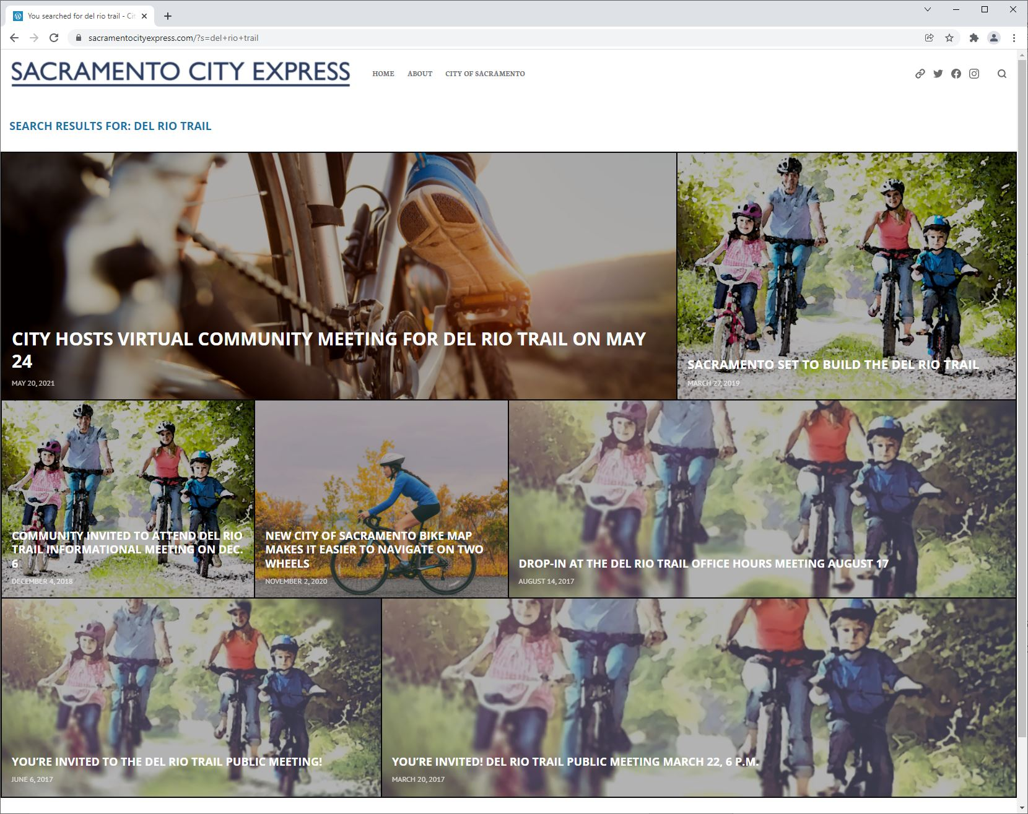
This is a priority project for the City of Sacramento and will continue to be advertised in press releases, social media posts, newsletters, e-blasts, and Sacramento City Express (the City’s public blog). A ribbon cutting will be part of the project including an “opening day” bike ride along the trail.

A.7 MAINTENACE PLAN
The trail is being designed for a pavement lifespan of no less than forty years, although proper maintenance of the corridor will likely mean that the trail is in the City of Sacramento in perpetuity. The trail and its shoulders will be maintained by the Department of Public Works, and the park space will be maintained by the Youth, Parks, and Community Enrichment Department. Both departments will maintain their respective portions of the project from their general operating funds.

The artwork portion of the project will be maintained through the City of Sacramento’s Art in Public Places (APP) program. Established originally in 1978, this program includes over 400 artworks in its permanent collection along with ongoing temporary work. Per the City’s policy, any permanent artwork in the city’s collection is maintained by the APP program. APP monitors artwork condition and provides repairs, regular maintenance, restoration, and in rare circumstances decommissioning of permanent artwork.

The artwork created through this grant will be permanent and will be maintained by APP. When working with artists, we encourage when possible that artists use materials and techniques that will weather well and do not require regular maintenance. The program has a maintenance fund to cover the costs of maintenance, and APP will contract with local conservators and maintenance staff to maintain the work over time.

The project will plant 700 new trees along the corridor, and their establishment will be incorporated in the general contractor’s scope of work per the City’s Standard Specifications. Trees that fail to establish will be replaced at the contractor’s expense.

It is the intent of the project to activate what is currently an abandoned railroad corridor with a significant amount of bicyclist and pedestrian traffic. This change in use will deter illegal dumping with additional eyes on the trail and the ability for Park Rangers to patrol the corridor. Trash receptacles will be included with the project to reduce littering. It is not expected that the project will completely alleviate litter and illegal dumping, but the construction of the trail will improve accessibility for City Maintenance crews and make it much easier to respond to and remove.

